**INDUSTRY AUTOMATION BASED ONLINE SUMMER INTERNSHIP PROGRAM**

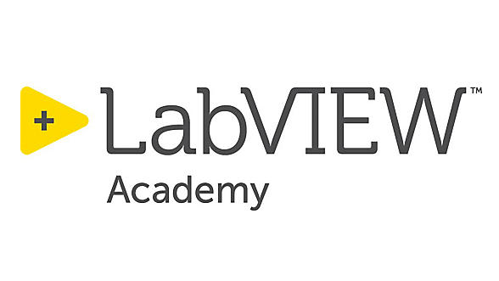

A Summer Internship Program Reports

Submitted in Partial Fulfilment of the Requirement for the B.Tech

(Branch Name)

Year

2020-2021

Conducted by

National Instruments Innovation Center

Center of Excellence ITSEC Greater Noida

**Submitted By**

Mr. Nitesh Pradhan

Trainer & Coordinator

NI Innovation center

**Submitted To**

Mr. Nitesh Pradhan

Trainer & Coordinator

NI Innovation center

**CERTIFICATE**

This is to certify that the Summer Internship reports entitled **Industry Automation Based Online Summer Internship Program** Submitted to National Instruments Innovation Center, ITSEC Greater Noida in Partial Fulfilment of the Requirement for the B.Tech (Branch Name) is an original work carried out by Mr.Ms/ ……………………………., under the guidance of **Mr. Nitesh Pradhan** Trainer and coordinator of NI innovation center. The matter embodied in these reports is a genuine work done by the Mr./Ms……………..

**Signature of Coordinator**

Mr. Nitesh Pradhan

Trainer & Coordinator

NI Innovation center

**Signature of Student**

**ACKNOWLEDGEMENT**

>>

**INDEX**

1. Introduction.
2. Industry automation

2.1 Automation

2.2 Robotics Vs automation

2.3. Types of industry automation

2.4 Benefit of industry automation

2.5 Requirement of industry automation.

1. Virtual Instrumentation

3.1 What is Virtual Instrumentation

3.2 Benefit of Virtual Instrumentation

3.3 Requirement of Virtual Instrumentation

1. Virtual Programming Platform
2. LabVIEW
   1. What is LabVIEW
   2. LabVIEW Data Type
   3. Array & Cluster
   4. Loops
   5. Case structure
   6. SubVI
   7. File IO
   8. Data Acquisition
   9. Event
   10. State machine algorithm
   11. Sequential Programming
3. List of programs.
   1. Average of two & N Number
   2. Hello word
   3. Name Add
   4. LED ON/OFF
   5. Odd even
   6. Function generator
   7. Table
   8. Table in range
   9. Name to binary
   10. Fibonacci series
   11. Lucky Draw Number
   12. Object Count
   13. Pattern count
   14. Basic child learning Program
   15. File Read
   16. File Write
   17. Data acquire 1 channel
   18. Data acquire N channel
   19. Data acquire 1 channel store
   20. Data acquire N channel store in text file
   21. Data acquire N channel store in .csv file
   22. Data base design
   23. Data base update
   24. Folder design
   25. Song (.Wav file) Play
   26. Video Player
   27. Text to voice converter
   28. F to C converter
   29. Fan speed control
   30. Dice control
   31. Car speed control
   32. LED Move in square
   33. Event based data acquisition
   34. Analog watch
   35. Tik-toc Game
   36. Data Sent into Cloud (IOT)
   37. Data received from cloud (IOT)
   38. Calculator program
4. Project
   1. Project Aim and Intro
   2. Project description
   3. FP/ BD
5. Outcome
6. Reference

Fig- 2.1 Name

Summer Internship Report - IILMhttps://www.iilm.edu › download › Placement-SIP...

PDF

Executive Summary. The 3-months Summer Internship Program at IILM Institute for Higher Education is a vital part of the 2-year. PGDM Course. Since majority of​ ...

Missing: .df